

ASSET VERIFICATION AND RECORDING TOOL KIT


Plot 31, Bukoto Street
P.O Box 7657, Kampala, Uganda
+256 (0) 39 2000216/0772525235
email: cpa@cpa.ug

www.cpa.com

August to September 2026

VERIFICATION DETAILS

NAME OF THE REGION: | EASTERN REGION
SUB-REGION: | BUSOGA
Name of Local Government | MAYUGE DISTRICT LOCAL GOVERNMENT
VERIFIER PARTICULARS
Full name | MR. KIYUBA SALIMU
Contact/ email and Telephone | kiyubasilimu@gmail.com/0755215778
Supervisor/ Sub team leader | Nandudu sulaina
Name | WANDERA SOLOMON
Contact | 0708153235
Date of submission | 26/08/2026

HEALTH CENTRES
INFORMANT INTERVIEW/DISCUSSION GUIDE (INCHARGE OR RESPONSIBLE PERSON)

Name of Health Centre: BUKATUBE HEALTH CENTER III

1a | Does the Facility have a record of all assets provided under UgIFT.  (Obtain a record and verify if it has the costs and numbers supplied | YES
1b | If Not ask how many were supplied and when.

2 | How does this facility Maintain (repair/service/replace) the assets provided under Ugift  The facility equipment is usually maintained, repaired, and replaced by the in charge.

3 | Does the facility take regular record about functionality/ or breakdown of the assets provided? | Yes

4 | How has the UgIFT support helped in service delivery in the area, any issues, challenges and any recommendations for better program implementation. | The UgIFT has consistently helped in supplying health equipment to the facility and this has eased admissions hence managing the overwhelming at the facility.  It has also helped in the accommodations of staff by building staff quarters near the facility. This has reduced absenteeism at the facility since officials are ever present at the facility.  It also generally increased the health workers at the facility hence reducing the overwhelming health to patient ratio.  It has also helped in good sanitation because of the increased number of assets at the facility like the placenta pits, pit latrines and bathrooms for patient.  Labor wards and available equipements for labor such as labor beds and labor suits have created enough space for mothers in labor hence reducing congestion.  Because of the available equipements, and assets the facility can now handle overwhelming admissions hence reducing unnecessary referrals. However, the facility has always hard issues and challenges which include:  - The Lab is generally very small hence causing delay in service.  - Inadequate inventory store at the facility and has forced the facility to improvise the men’s ward into a store and the men are now admitted together with ladies in the same female ward.  - Adult beds are not enough. They only have 4 yet averagely on a single day, 70 patients are received.  - Theft and threats attributed to lack of a perimeter fence. Hence putting health officers and patients at stake.  - Stock Outs and delays of restocking is really a big challenge hence hindering admissions and normal treating of the patients.  Notwithstanding,  i. we recommend that the OPD facility be increased to reduce the overwhelming daily admissions at the facility.  ii. we also recommend a perimeter wall to be installed at the facility since they lack one to improve on the security

PROCEED TO VERIFICATION AFTER THIS DISCUSSION

Health centre checklist

NAME OF LG MAYUGE DISTRICT LOCAL GOVERNMENT

NAME OF HEALTH FACILITY: BUKATUBE HEALTH CENTER III

Equipment/ Item | Department | Asset Number | Item  Description | Life in Months | Tag Number ( engrave no.) | Date Of Purchase | Date Placed In Service | Recoverable cost | Cost | Acc Dep Cost | Net Book Value | Ytd Deprn | Equipment status | Remarks
B.P. Machine, Digital | health |  | It is white in color model 2088C with a black surface and a rectangular screen |  | Not Engraved | 1st/May/2016 |  |  |  |  |  |  | Good and functional. | Both of the 2 machines were verified
B.P. Machine (Aneroid wall mounted) | health |  | It has a gauge, white in color, with a black metallic base mounted on the wall |  | Not engraved | 1st/May/2016 |  |  |  |  |  |  | Good and functional. | Both of the 2 machines were verified
Autoclave 20 Liters.,Duo Operated | health |  | Silver cylindrical stainless bowl with a round top and black handles with a gauge. |  | Not engraved | 1st/May/2016 |  |  |  |  |  |  | Faulty and need repair | Well verified
Bowl, Kick | health |  | Standard silver steel medical bowl with mobile kick stand. |  | Not engraved | 1st/May/2016 |  |  |  |  |  |  | Good and functional. | One received and verified.
Bowl Stand | health |  | Standard double bowl size with 2 bowls |  | Not engraved | 1st/May/2016 |  |  |  |  |  |  | Good and functional | 6 bowls 3received and all verified,
Counting chamber Neubauer- Improved |  |  |  |  |  |  |  |  |  |  |  |  |  | Not verified
Cupboard Steel, Lockable | health |  | Standard grey metallic steel cupboard with lockable double door and adjustable shelves. |  | Not engraved | O5/7/2023 |  |  |  |  |  |  | Good and functional | Only one verified and in use`
Drip Stand | health |  | It is a grey metallic drip stand with adjustable heights, 4 hooks on top with 5 castor wheels for mobility. |  | Not engraved | 1st/May/2016 |  |  |  |  |  |  | Good and functional | 7 received and verified
ESR Stand | health |  | A standard metallic grey metal with adjustable leveling for holding tubes. |  | Not engraved | 1st/May/2016 |  |  |  |  |  |  | Good and functional | One received and verified,
Examination Couch | health |  | A standard grey metallic frame table with black mattress on top, adjustable with a handle. |  | Not engraved | 1st/May/2016 |  |  |  |  |  |  | Good and functional | 4 received and verified
Examination light,LED | health |  | A metallic stand light with bright white led light, adjustable head used for examining patients |  | Not engraved | 1st/May/2016 |  |  |  |  |  |  | Good and functional | 3 received and only 2 verified.
Glucometer | health |  | A small black portable machine with screen and test strips . |  | Not engraved | 1st/May/2016 |  |  |  |  |  |  | Good and functional | 2 received, verified and not in use.
Haemoglobin Meter, Digital | health |  | A small portable handheld device, white and grey plastic with screen on top. |  | Not engraved | 1st/May/2016 |  |  |  |  |  |  | Good and functional | 2 received, both in use and verified
Height Meter | health |  | A tall vertical metallic stand, silver in color with flat base and sliding head and height scale. |  |  | O5/7/2023 |  |  |  |  |  |  | Good and functional | 3 receive, verified and in use
Instrument Trolley | health |  | Medium sized, Grey in color with 2 compartments , the lower one bigger than the upper one |  | Not engraved | 1st/May/2016 |  |  |  |  |  |  | Good and functional | 4 received and only 2 verified and in use.
Microscope Binocular | health |  | A black and grey metallic device with double eye pieces on top, round base, lenses, knob. |  | Not engraved | 1st/May/2016 |  |  |  |  |  |  | Good and functional | 1 received verified and in use.
Otoscope | health |  | A small handheld black plastic device, torch like shape with light head on top and pocket sized. |  | Not engraved | 1st/May/2016 |  |  |  |  |  |  | functional | 1 received but Verified, in use.
Patient Screen | health |  | A metallic folding frame, blue cloth, 3- panel, stands on 4 wheels. |  | Not engraved | 1st/May/2016 |  |  |  |  |  |  | Good and functional | 5 received, in use and verified
Patient Trolley | health |  | A rectangular stainless steel frame, silver metallic with 2 selves, 4 wheels with 2 lockable, medium sizes with a push handle. |  | Not engraved | 1st/May/2016 |  |  |  |  |  |  | Good and functional | 1received verified and in use.
Refrigerator, Basic | Health |  | Medium size upright electric device, grey metallic outer body with single door and selves. |  | Not engraved | O5/7/2023 |  |  |  |  |  |  | Good and functional | 1 verified and in use.
Stethoscope | Health |  | Black in color with 2 rubber flexible tube |  | Not engraved | 1st/May/2016 |  |  |  |  |  |  | Good and functional but 1 faulty and repaired | 8 received, 7verified and 1 faulty.
Stop Watch | health |  | Handheld digital timer with start, stop and reset function. |  | Not engraved | 1st/May/2016 |  |  |  |  |  |  | Not seen | 1 received but not verified.
Stretcher | Health |  | It’s a bed with 4 black wheels ,two rails and black soft sponge |  | Not engraved | 1st/May/2016 |  |  |  |  |  |  | Good and functional | 1 received, verified and in use.
Stove, Gas | health |  | White in color, 6kg(stabex) with 4 metallic banners |  | Not engraved | 1st/May/2016 |  |  |  |  |  |  | Not seen. | 2 received but not verified.
Weighing Scale with Height Meter, Adult | health |  | Tall, White in color, automated with a height and a gauge. With a black rectangular base in nature |  | Not engraved | 1st/May/2016 |  |  |  |  |  |  | Good and functional | 2 received and 1 verified, in use
Weighing Scale, Infant | health |  | It’s a digital scale with a small white plastic tray |  | Not engraved | 1st/May/2016 |  |  |  |  |  |  | Faulty and not repaired. | 2 received and 1 verified and faulty.
Weighing Scale, Toddler | health |  | Medium, white tray size about 60cm by 30cm. |  | Not engraved | 1st/May/2016 |  |  |  |  |  |  | not | 1 received but not verified.
Wheel Chair | health |  | Medium, Black in color, foldable chair, with 2 back wheels, 2 foot pads and 2 handles |  | Not engraved | 1st/May/2016 |  |  |  |  |  |  | Good and functional | 4 revived , in used and verified
Audio Visual Equipment | health |  |  |  | Not engraved | 1st/May/2016 |  |  |  |  |  |  |  | Not received, not verified.
Medical Waste Bin | health |  | Medium 20litre, plastic bin with a footpad. |  | Not engraved | 1st/May/2016 |  |  |  |  |  |  | Good and functional | 20 received, in use all verified
Wall Clock | health |  | A round white dial device, black numbers and hands, plastic body with glass cover and wall hanging. |  | Not engraved | O5/7/2023 |  |  |  |  |  |  | Good and functional | 3 received, all in use and all verified
Diagnostic Equipment Set for MCH | health |  | Small, portable, black bag that contains BP machine, thermometer, torch, tape measure. |  | Not engraved | 1st/May/2016 |  |  |  |  |  |  | Good and functional | 2 received, in use and verified.
Diagnostic Equipment Set for OPD | health |  | Small portable, silver metal tools for general OPD examination. |  | Not engraved | 1st/May/2016 |  |  |  |  |  |  | Good and functional | 2 received, verified and not in use.
Glassware Set, Laboratory, Basic | health |  | Small, transparent glass containing, beakers, test tubes, measuring cylinder, slides and petri dishes |  | Not engraved | 1st/May/2016 |  |  |  |  |  |  | Good and functional | 2 received, verified and not in use.
Hollow Ware Set, Treatment | health |  | Medium set containing kidney dishes, gallipots, instrument trays and bowls |  | Not engraved | 1st/May/2016 |  |  |  |  |  |  | Good and functional | 2 received, verified and not in use.
Instrument Set, Dressing | health |  | Small set, sliver, metallic tray containing scissors, forceps, needle holder. |  | Not engraved | 1st/May/2016 |  |  |  |  |  |  | Good and functional | 4 received, 2 verified and in use.
Instrument Set, Basic ENT |  |  |  |  |  |  |  |  |  |  |  |  | Not seen. | 1 received, not verified.
Instrument Set, Suture | health |  | Small size stainless steel, silver in color containing needle holder, scissors and forceps for suturing wounds. |  | Not engraved | 1st/May/2016 |  |  |  |  |  |  | Good and functional | 3 received, verified and in use
Pulse Oximeter, Hand held | health |  | Small portable size, white and blue color with finger probe for measuring oxygen saturation and pulse |  | Not engraved | 1st/May/2016 |  |  |  |  |  |  | Good and functional | 2 received, verified and not in use because they have never received a patient for the use.
Bed, Adult Patient with Mattress |  |  | Standard single beds with black mattress, grey metallic frame and manually adjustable. |  | Not engraved | 1st/May/2016 |  |  |  |  |  |  | Good and functional | 10 verified and in use.
Bed, Pediatric Patient, With Mattress | health |  | White in color with blue soft sponge mattress, white metallic frame and side rails. |  | Not engraved | 1st/May/2016 |  |  |  |  |  |  | Good and functional. | 4 received, verified and in use verified
Bedside Locker | health |  | A small square metallic device, light grey color with one drawer on top and one small cabinet door with 4 stands |  | Not engraved | 1st/May/2016 |  |  |  |  |  |  | Good and functional | 10 received, verified and in use.
Cupboard, Instrument | health |  | A tall upright metallic device, white and grey, double glass doors on top, double metal doors. |  | Not engraved | 1st/May/2016 |  |  |  |  |  |  | Good and functional | 1 received, verified and in use.
Delivery Bed, Hydraulic Manual | health |  | A large metallic bed device, blue mattress top with adjustable backrest and leg rests and side rails. |  | Not engraved | 1st/May/2016 |  |  |  |  |  |  | Good and functional | 1 received, verified and in use
Oxygen Therapy Apparatus, Mininum 45L cylinder | health |  | A tall green metallic gas cylinder device, with regulator, a gauge on top and a tubing. |  | Not engraved | 1st/May/2016 |  |  |  |  |  |  | Good and functional | 2 received, 1 verified and not in use because of lack of power.
Resuscitator Manual, Infant, with all Mask sizes | health |  | A small handheld silicone device, transparent bag with blue valve. |  | Not engraved | 1st/May/2016 |  |  |  |  |  |  | Good and functional | 2 received, verified and not in use.
Resuscitator Manual, Adult, with all mask sizes | health |  | A light handheld silicone device, transparent bag with blue valve. |  | Not engraved | 1st/May/2016 |  |  |  |  |  |  | Good and functional | 2 received, verified and not in use
Suction Apparatus, (Electric) | health |  | It is an electric pump, White, with 2 bags of water and a guage.  Model COO1-A with 4 wheels |  | Not engraved | O5/7/2023 |  |  |  |  |  |  | Good and functional | 1 received, verified and not in use.
Nebulizer, Ultrasonic | health |  | Small tabletops size with white color ultrasonic with adult and child mask set |  | Not engraved | 1st/May/2016 |  |  |  |  |  |  | Good and functional | 1 received, verified and not in use
Oxygen Concentrator, Duo Flow | health |  | Medium size, Grey, 2 handles on top and a cylinder also on top. With outlets and wheels at the bottom |  | Not engraved | 1st/May/2016 |  |  |  |  |  |  | Good and functional | 1 received, verified and in use
Bench | health |  | Black soft sponge with brown wooden stands |  | Not engraved | 1st/May/2016 |  |  |  |  |  |  | Good and functional | 4 received, verified and in use
Disinfection Buckets | health |  | A set of large plastic buckets, blue in color with lids. |  | Not engraved | 1st/May/2016 |  |  |  |  |  |  | Good and functional | 6 received, verified and in use
Baby Cot | health |  | A small metallic infant bed device, white steel frame, with transparent sides on 4 wheels with mattress. |  | Not engraved | 1st/May/2016 |  |  |  |  |  |  | Good and functional | 2 received, verified and in use
Diagnostic Equipment Set for Ward | health |  | A portable metric kit containing stethoscope, clinical thermometer, torch, and plastic materials. |  | Not engraved | 1st/May/2016 |  |  |  |  |  |  | Good and functional | 2 received, verified and in use.
Hollow Ware Set, Ward | health |  | A large steel set, silver color containing kidney dish, bowl and tray of different sizes on a tray. |  | Not engraved | 1st/May/2016 |  |  |  |  |  |  | Good and functional | 2 received, verified and 1 in use.
Instrument Set, Delivery | health |  | A medium steel set, silver color containing scissors, forceps, cord clamps, kidney dish in a steel tray. |  | Not engraved | 1st/May/2016 |  |  |  |  |  |  | Good and functional | 2 received, verified and in use.
Instrument Set, Stitch Removing | health |  | Small size 3 pieces, silver steel tray with stitch scissors, kidney dish and toothed forceps |  | Not engraved | 1st/May/2016 |  |  |  |  |  |  | Good and functional | 3 received, verified and 1 in use.
MVA Kit | health |  | Small white plastic manual vacuum aspirator kit with syringe 4-12mm cannula for evacuation. |  | Not engraved | 1st/May/2016 |  |  |  |  |  |  | Good and functional | 5 received, 4 verified and not in use
Stool, Laboratory | health |  | Standard size, high, silver with 5 wheels and black in color |  | Not engraved | 1st/May/2016 |  |  |  |  |  |  | Good and functional | 3 received, verified and in use
Penguin Sucker | health |  | Small white rubber bulb for newborn suction. |  | Not engraved | 1st/May/2016 |  |  |  |  |  |  | Good and functional | 3 received, verified and 1 in use
Fetoscope, Dopplar | health |  | Handheld pocket size, white in color with a screen, display and speaker. |  | Not engraved | 1st/May/2016 |  |  |  |  |  |  | Good and functional | 2 received, verified and 1 in use
Bubble CPAP |  |  |  |  |  |  |  |  |  |  |  |  | Not seen | Not verified.
Centrifuge (Electric) | health |  | Small white plastic bench top small size digital machine |  | Not engraved | 1st/May/2016 |  |  |  |  |  |  | Good and functional | 1 received, verified and in use
Kangaroo Mother Care Chair | health |  | A large fabric reclining mother chair with silver metallic frame. |  | Not engraved | 1st/May/2016 |  |  |  |  |  |  | Good and functional | 1 received, verified and in use
Radiant Infant Warmer |  |  | . |  |  |  |  |  |  |  |  |  | Not seen | Not received, not verified.
Haemoglobin Meter, Sahli | health |  | Small black box kit, hand held with 2 tubes |  | Not engraved | 1st/May/2016 |  |  |  |  |  |  | Good and functional | 2 received, verified and 1 in use.
Delivery Bed | health |  | It is a manually adjustable bed.  Model H7 with peach mattress and a drip stand, grey metallic frame for delivery position. |  | Not engraved | 1st/May/2016 |  |  |  |  |  |  | Good and functional | 1 received, verified and in use
Examination light | health |  | Has a bulb on top with 5 wheels  Tall and mobile goose neck. |  | Not engraved | O5/7/2023 |  |  |  |  |  |  | Good and functional | 3 received, verified and in use
Instrument set, ENT Basic for HCIII | health |  | Small tray, silver steel containing otoscope, ear syringe, turning fork. |  | Not engraved | 1st/May/2016 |  |  |  |  |  |  | Good and functional | 1 received, verified and in use
Bag Valve mask (Ambu Bag), Neonatal | health |  | White, with yellow valve and a glass with white masks |  | Not engraved | 1st/May/2016 |  |  |  |  |  |  | Good and functional | 15 received, verified and 2 in use
Incubator |  |  |  |  |  |  |  |  |  |  |  |  | Not seen | Not received, not verified.
Office Chair | health |  | Black in color, swinging in nature with 5 black wheels |  | Not engraved | 1st/May/2016 |  |  |  |  |  |  | Good and functional | 7received, verified and in use
Desk |  |  |  |  |  |  |  |  |  |  |  |  |  | Not received
Filing Cabinet | health |  | Standard 4-drawer size, grey metallic color, |  | Not engraved | O5/7/2023 |  |  |  |  |  |  | Good and functional | 7received, verified and in use
Water tanks | health |  | cylindrical, one raise and one on ground, |  | Not engraved | 1st/May/2016 |  |  |  |  |  |  | Good and functional | 2 received, verified and in use
placenta pit | health |  | square cemented pit with a square coffee brown and yellow painted wall covering the pit . |  | Engraved  “placenta pit” | 1st/May/2016 |  |  |  |  |  |  | Good and functional  Good and functional | 1received, verified and in use  2received, verified and in use
Hash pit | health |  | it is a cemented circular pit |  | Not engraved | 1st/May/2016 |  |  |  |  |  |  | functional | 1 verified and in use
Staff quarters | health |  | Coffee brown and yellow color block with 2 bed rooms. |  | Not engraved |  |  |  |  |  |  |  | functional | Verified and in use
Pit latrines | health |  | 4 stances with a metallic door and coffee brown + yellow paint |  | Engraved  “female and “male” | 1st/May/2016 |  |  |  |  |  |  | functional | Verified and in use

ASSET VERIFICATION BRIEF REPORT

HEALTH CENTER: BUKATUBE HEALTH III,

CONDUCTED BY

WANDERA SOLOMON AND KIYUBA SALIMU

Introduction.

This brief report presents the findings of the physical asset verification exercise conducted at Bukatube health center III on 25TH/8/2026. The team was warmly welcomed by respondent, Mr. Kigenyi Jude (Clinical Officer) who was the focal person in this exercise assigned to us by the incharge

Findings.
- Key assets including all medical assets, furniture and buildings were physically verified and found present. However, those that were not physically verified were not received i.e. incubator, Desks, Counting chamber Neubauer, Bubble CPAP.etc.
- All the items were found to be functional and in good physical condition. However, it was observed that some of the equipment are currently stored and not yet in active use. Despite being stored, the equipment handling was not good. i.e. we observed a laboratory stool under a mango tree outside the health centre.
- lack of skills to use and operate some of the provided equipment at the facility

Challenges.
- Almost all the assets were not engraved thus making the verification exercise very hard because we could not establish whether what we verifying was for Gift of not.
- Limited storage space. The facility is facing a challenge of inadequate storage space for newly received equipment. This has led to congestion, difficulty in accessing specific items quickly and a risk of accidental damage if not handled carefully.
- The facility has inadequate accommodation for staff. The available staff quarters are not sufficient to accommodate all the critical staff required to be within the facility premises especially maternity and night duty staff
- Only I staff quarter building with 2 rooms is available

Recommendation.
- Provide an additional storage space or expedite installation and distribution of the equipment to decongest the store.
- Construct additional staff quarters to accommodate and retain critical staff foe effective 24hr delivery.
- Engravement on the assets should be done immediately as soon they receive the equipment for accountability.
- Train staff on how to use the some assets

Conclusion.
- The asset verification exercise was successfully completed with full staff from Mrs Gidudu Mriam. All critical assets were verified, are functional, in good condition and well handled.
- Addressing storage space, accommodation and training the staff on how to use equipements are the three high priority challenges and if addressed, they will greatly improve service delivery and asset management at Bukatube health center iii.

UgIFT Asset Verification Field Photo Gallery
Below is the Physical Evidence of Asset Verification under the UgIFT; Photographic Records for BUKATUBE Health Center III in MAYUGE District.
Site Photographs
No. | Asset Description | Photo of the Asset
1. | HOSPITAL BLOCK WITH THE MATERNITY WARD, ANTENATAL CARE, FAMILY PLANNING, CHILDREN WARD | 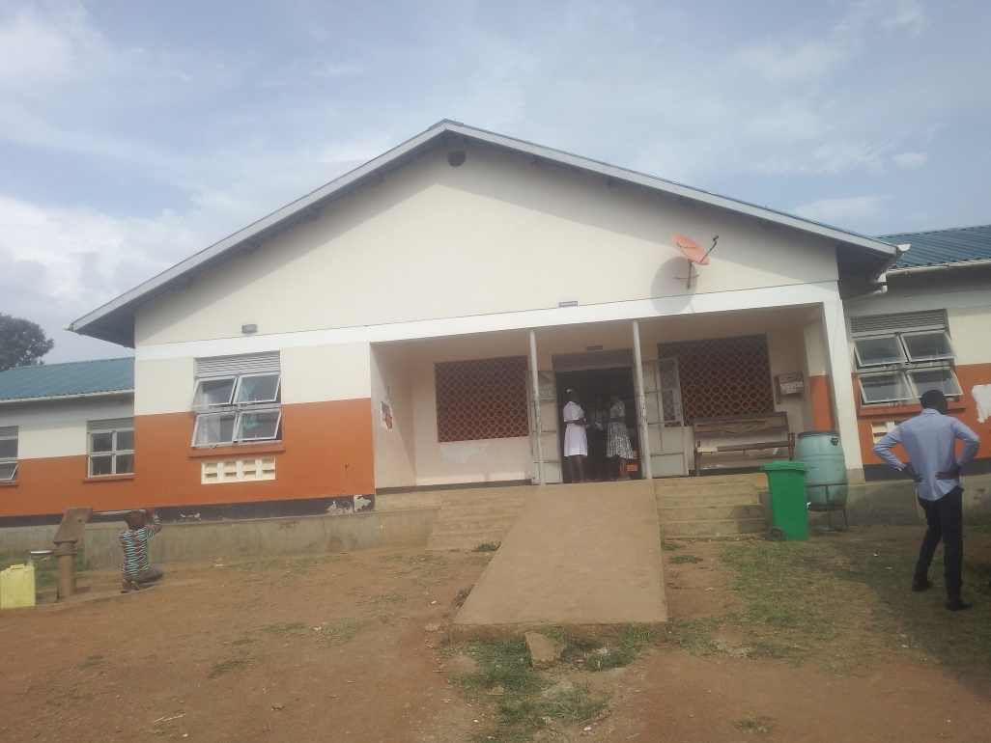
 | STAFF QUARTER’S BLOCK  WITH 2 ROOMS | 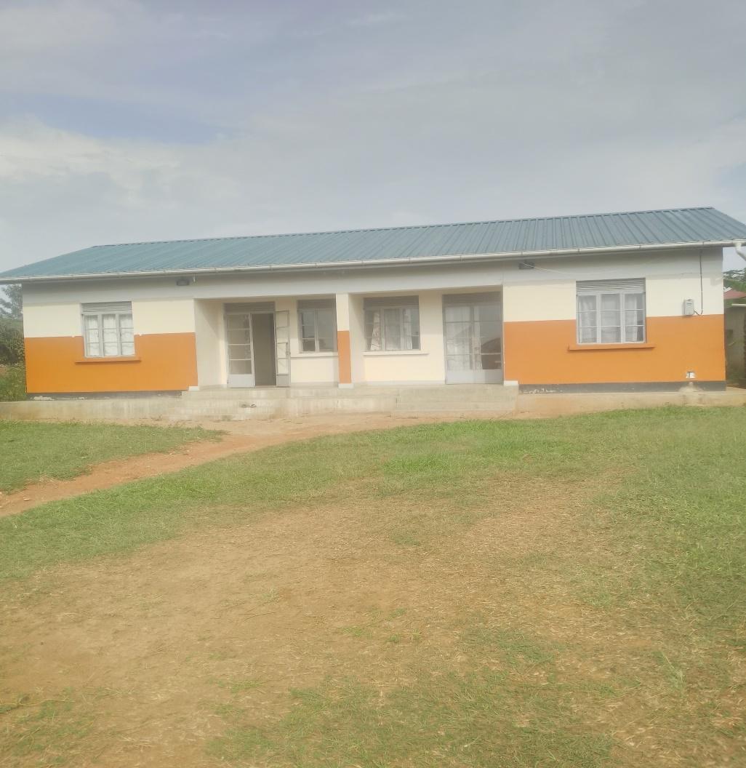
3. | TOILETS ENGRAVED “MALE” AND “FEMALE” | 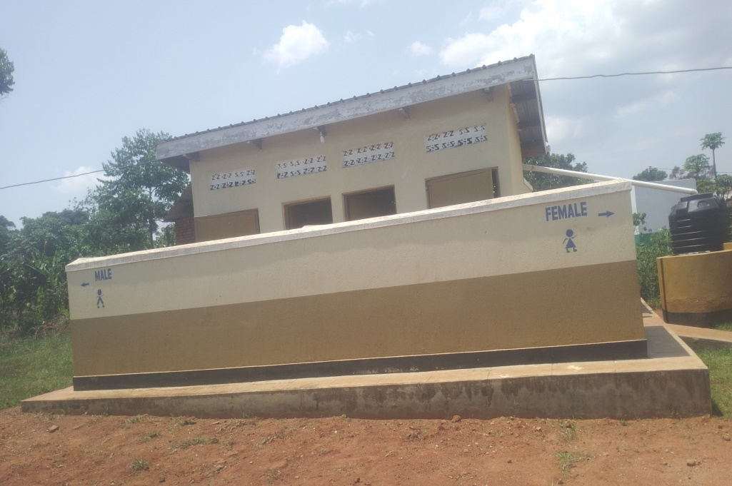z
4. | BIG TANK NEHING THE FACILITY BIG BUILDING  (NOT ENGRAVED) | 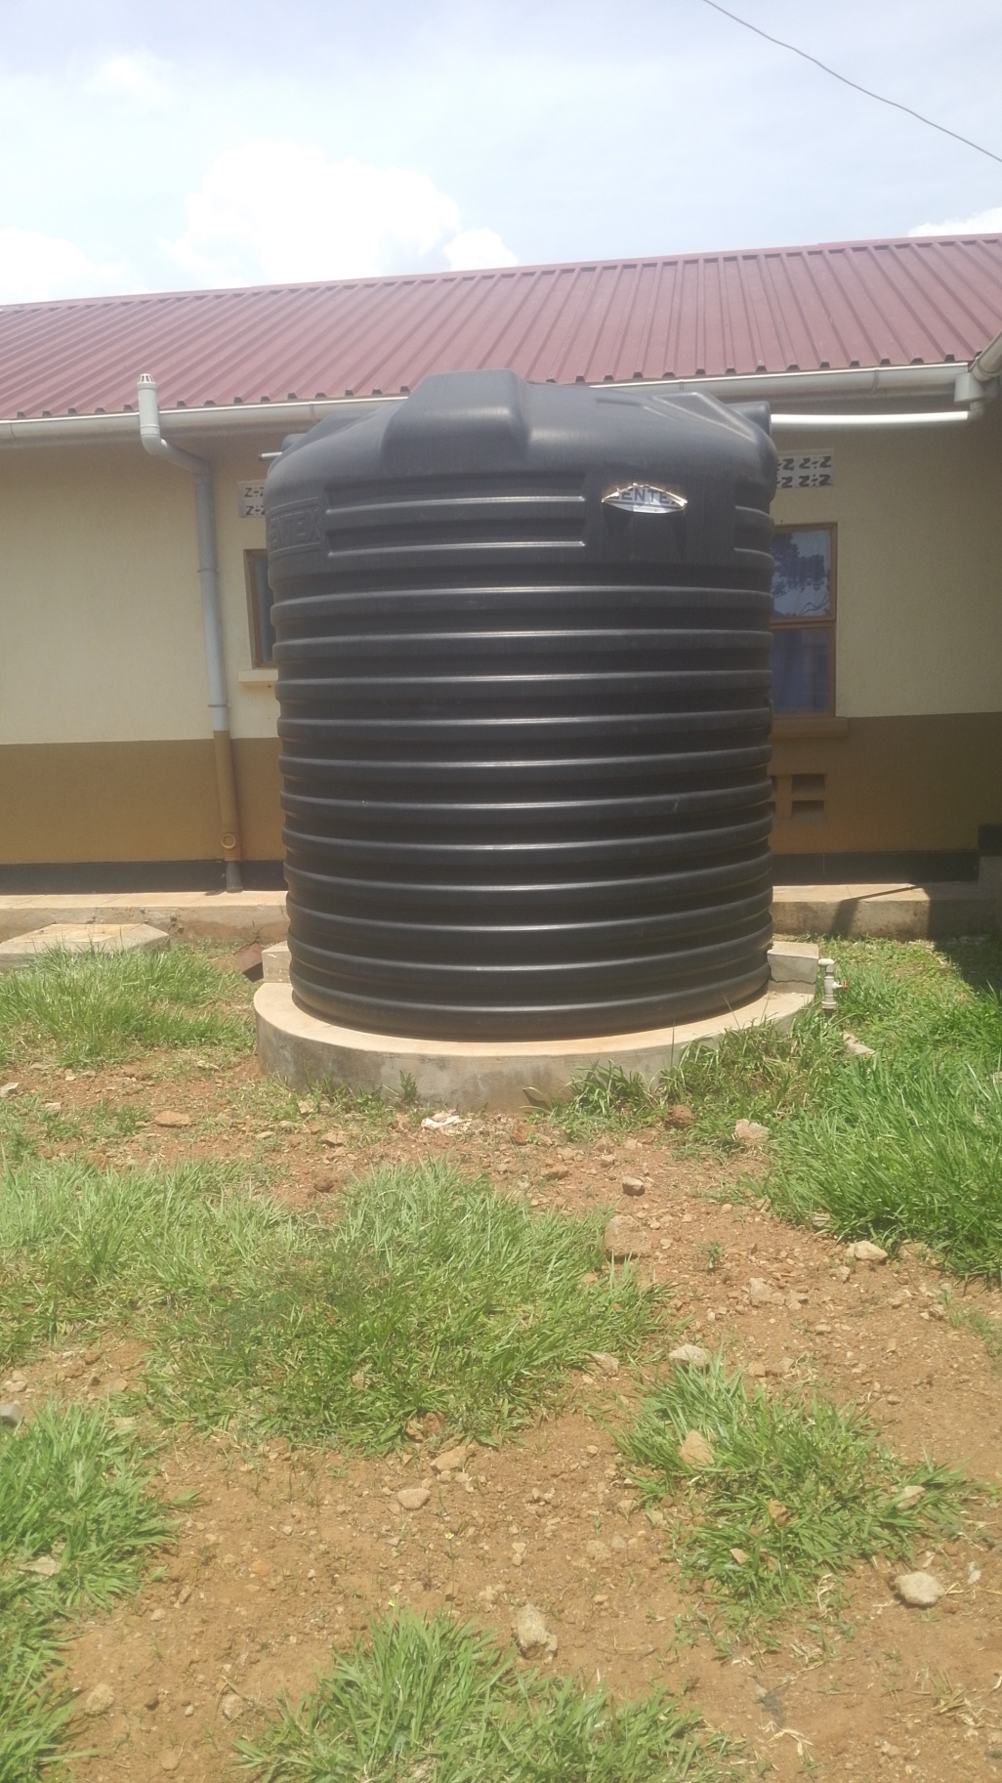
5. | A SMALL TANK RASED ON METALLIC STANDS  (NOT ENGRAVED) | 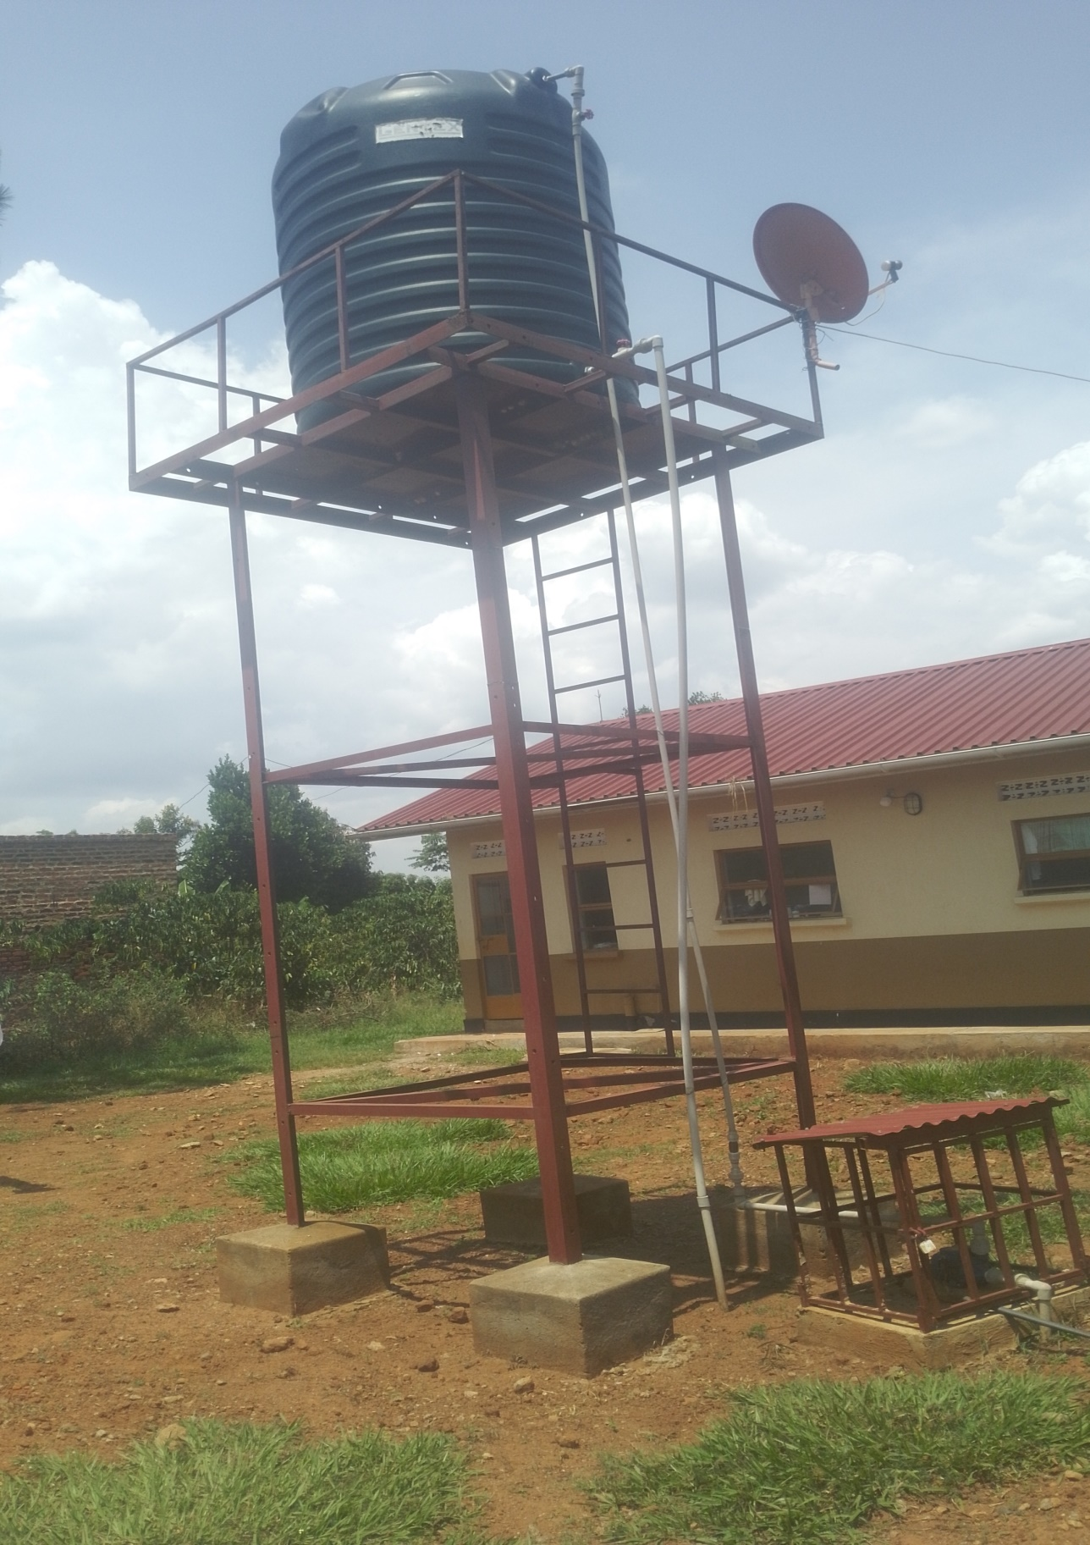
 | A SAMPLE OF THE MEDICAL WASTE BINS | 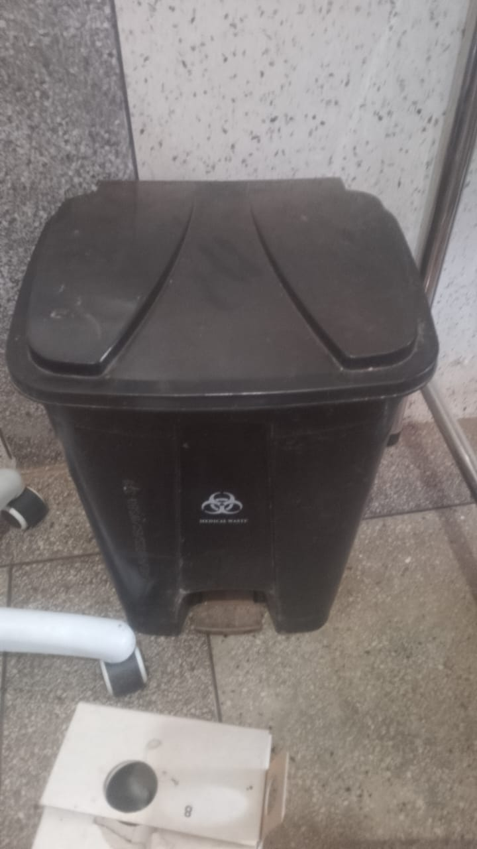
 | WALL CLOCK | 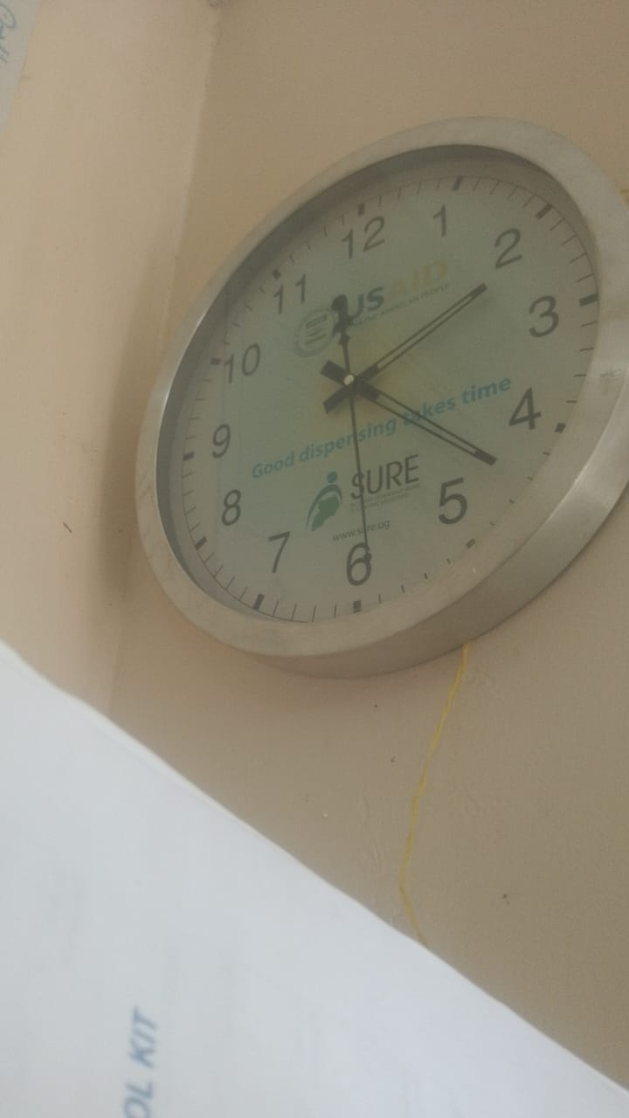
 | OFFICE HAIR | 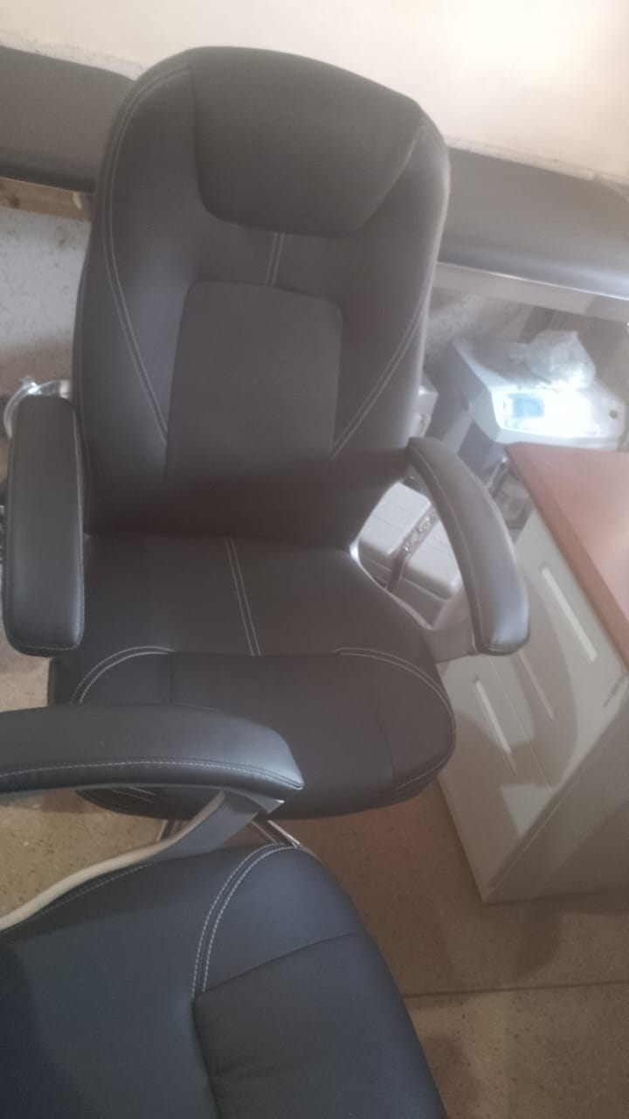
 | KANGAROO MOTHER CHAIR | 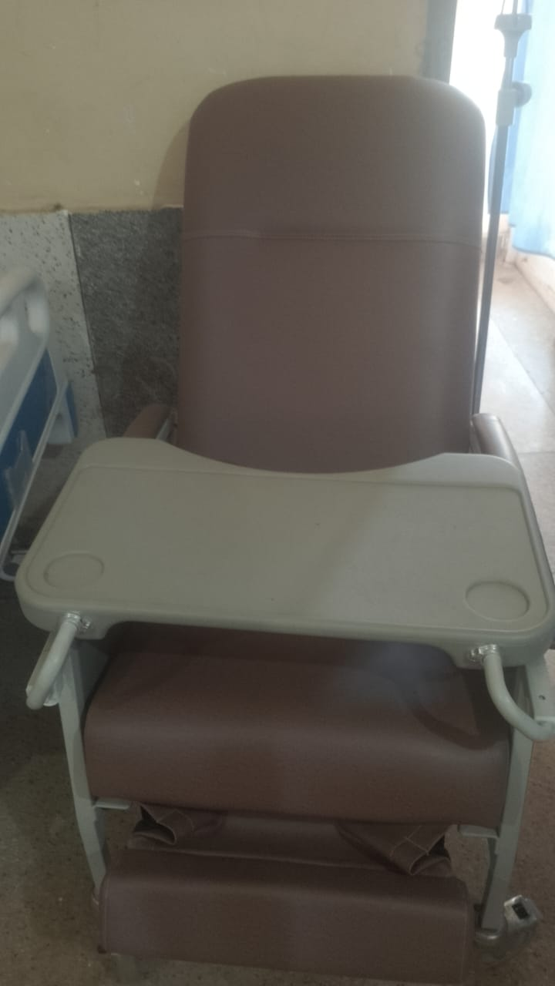
 | STRETCHER | 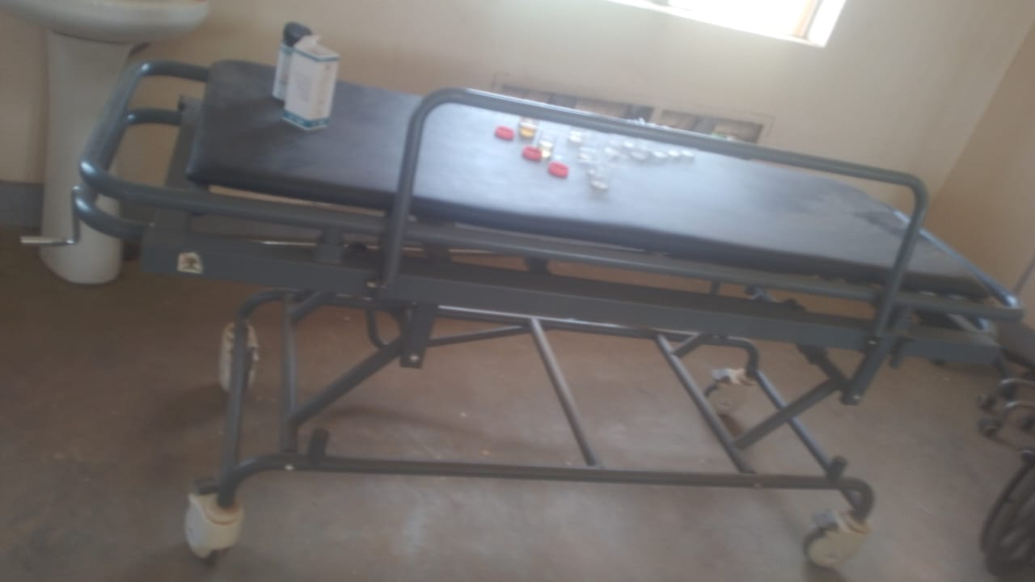
 | DELIVERY BED | 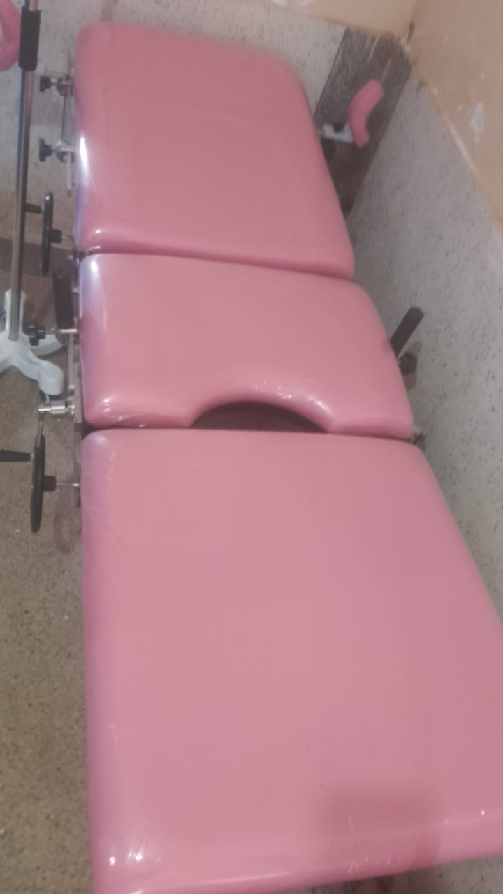
9. | PATIENT SCREEN | 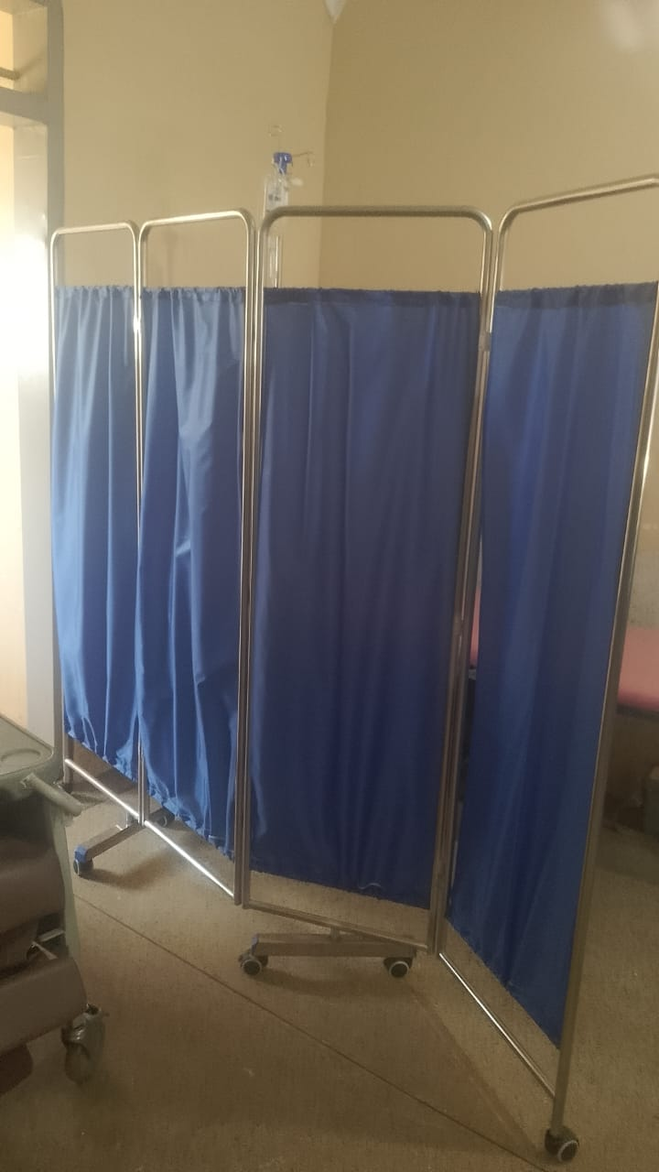
 | INSTRUMENT DRESSING TROLLEY WITH TWO BLUE BUKETS HANGING | 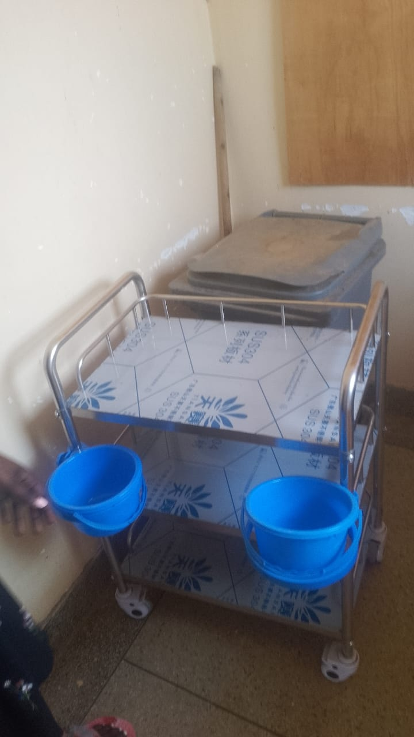
 | BOWL TROLLEY | 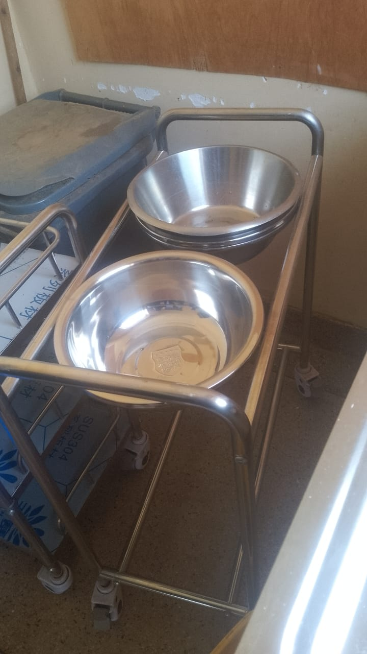
 | BABY COT | 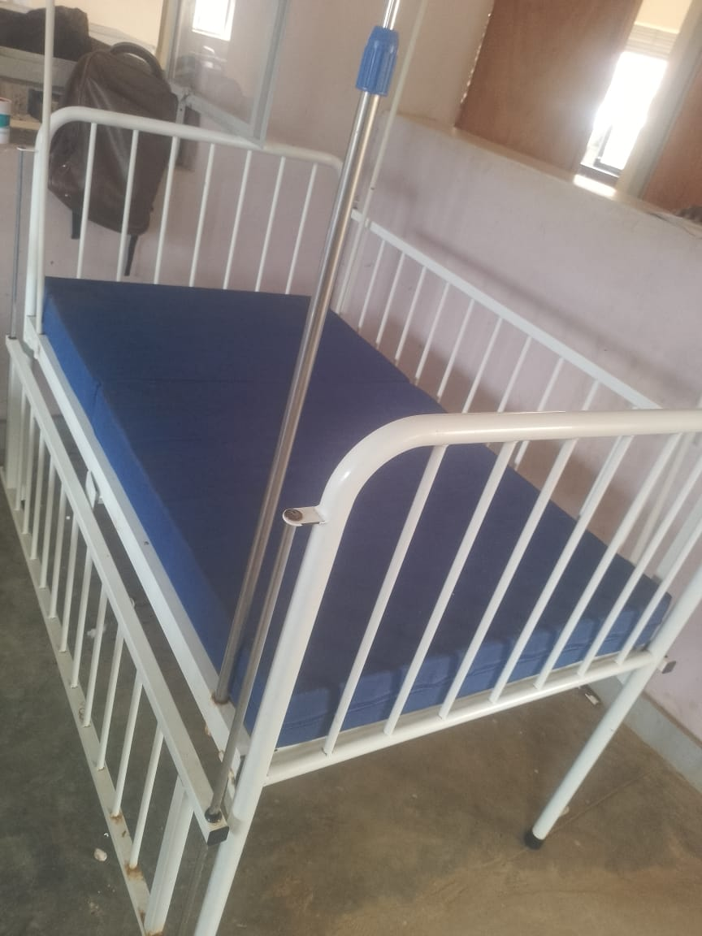
 | EXAMINATION LIGHT | 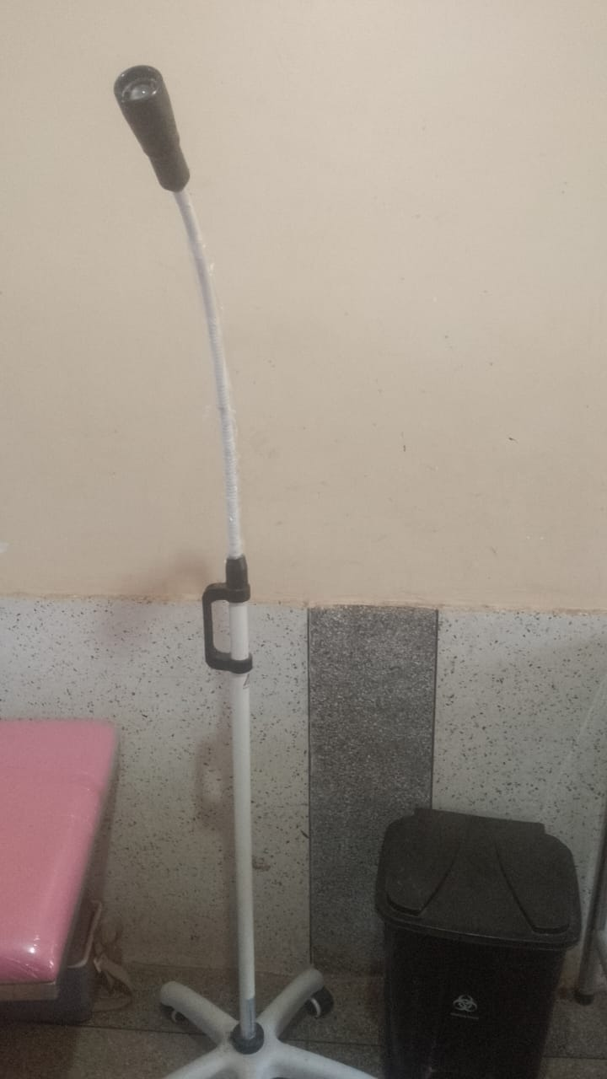
13. | WEIGHING SCALE INFANT | 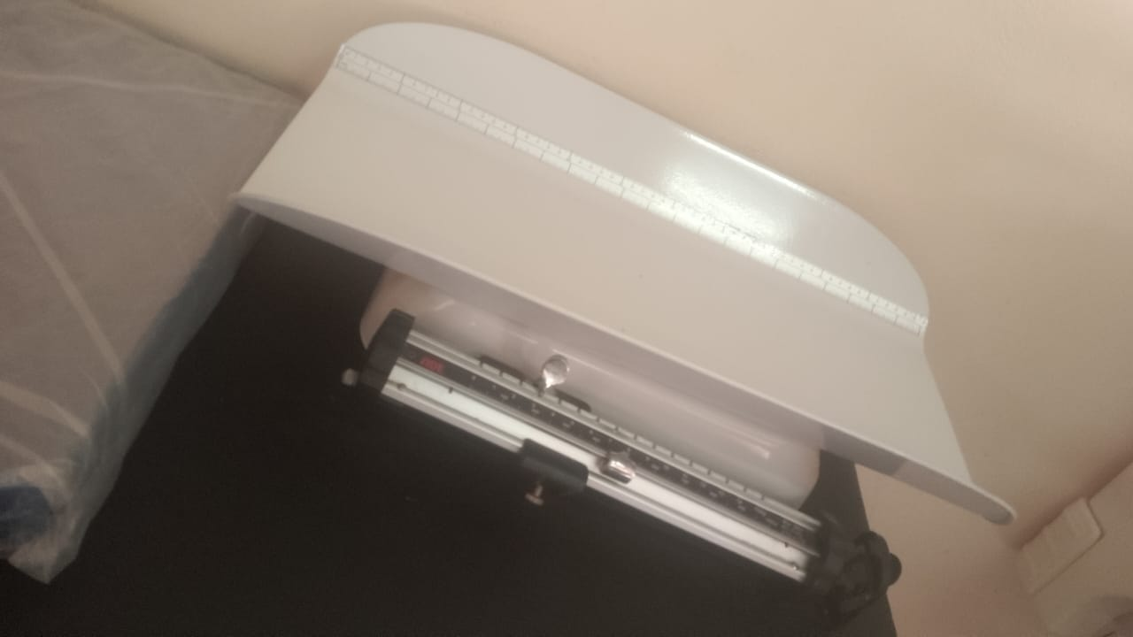
 | SUNCTION MACHINE | 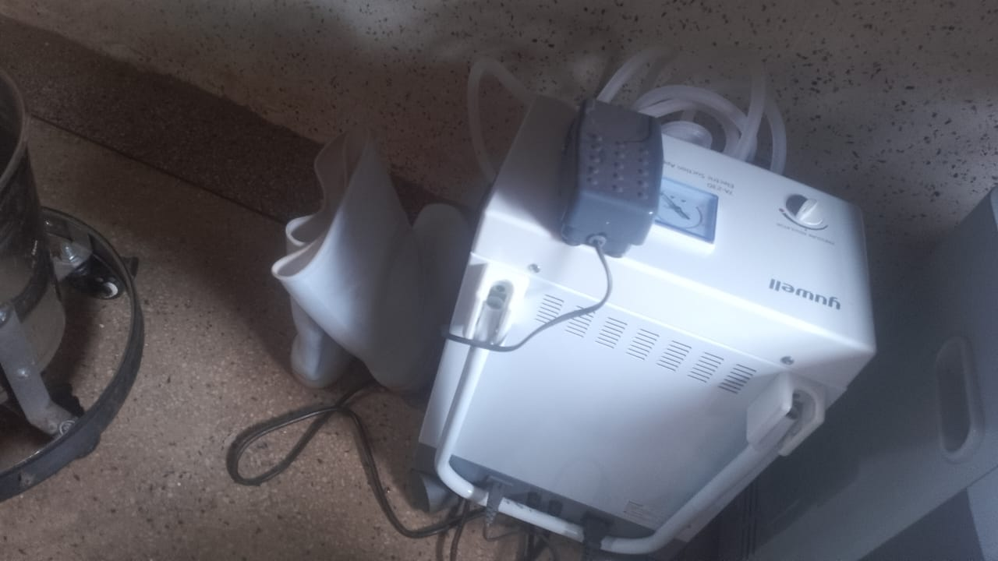
 | PENGUIN SUCKER | 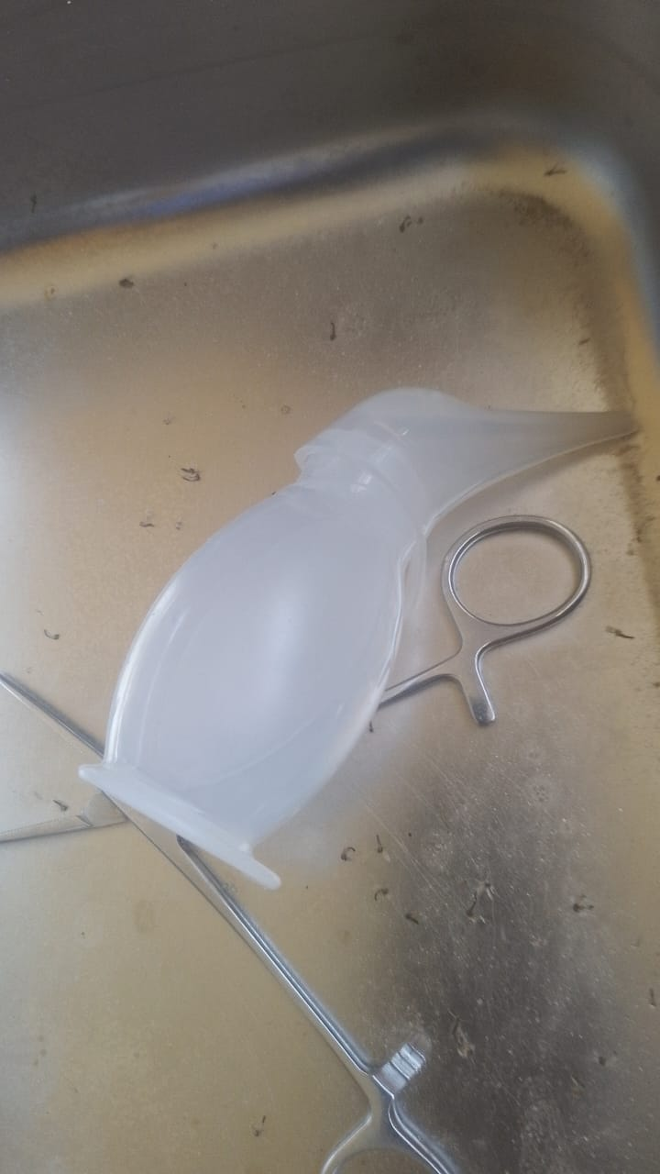
 | OXYGEN CONCETRATOR | 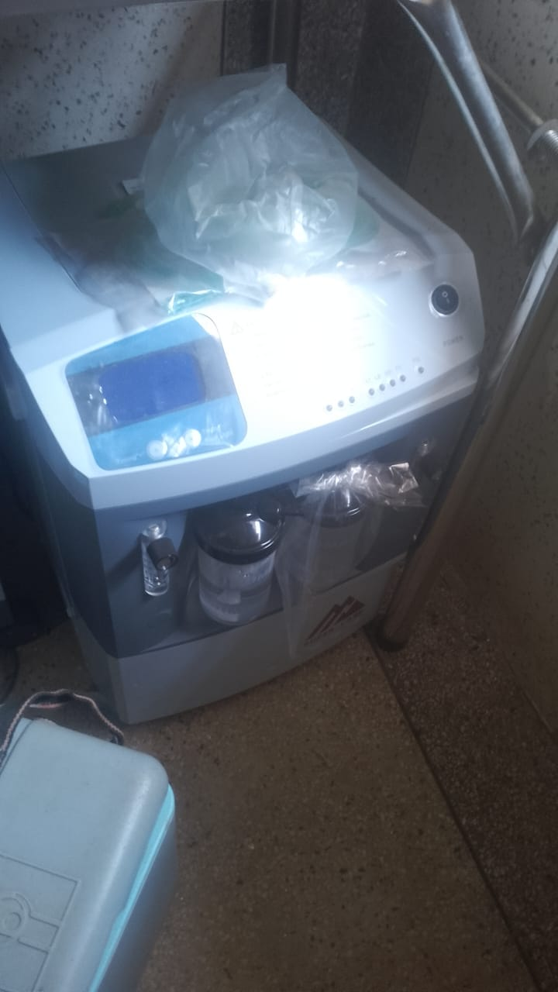
 | ELECTRICK AUTO CLAVE/STERILIZER PORTABLE PRESSURE TYPE | 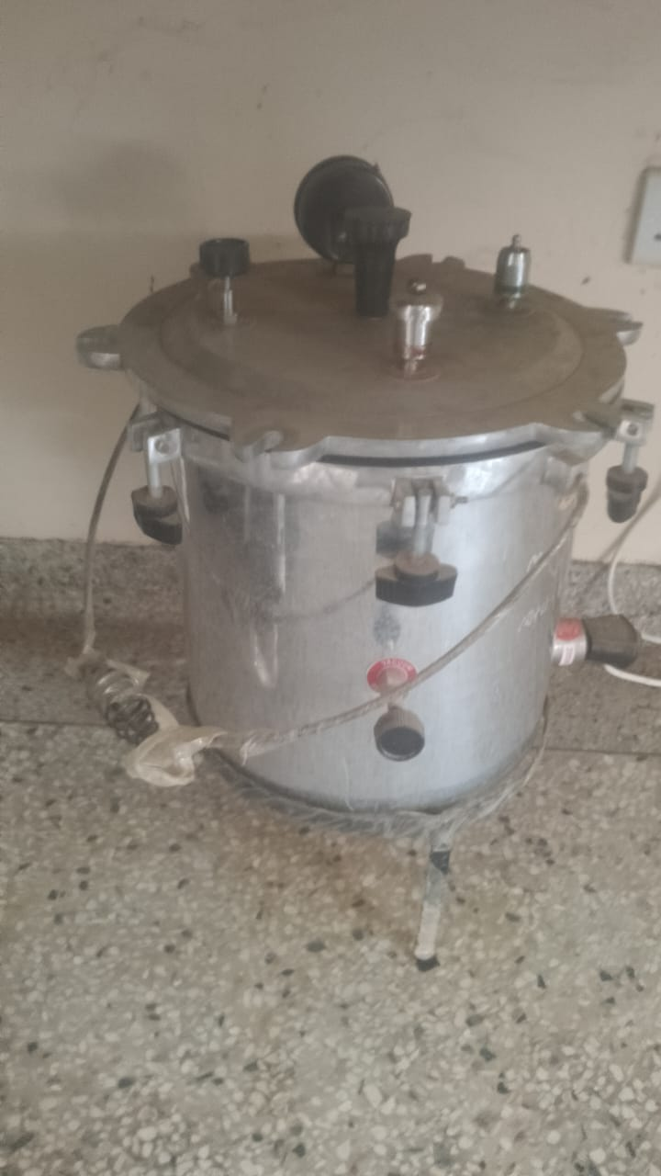
15. | CUPBOARD, STEEL LOCKABLE | 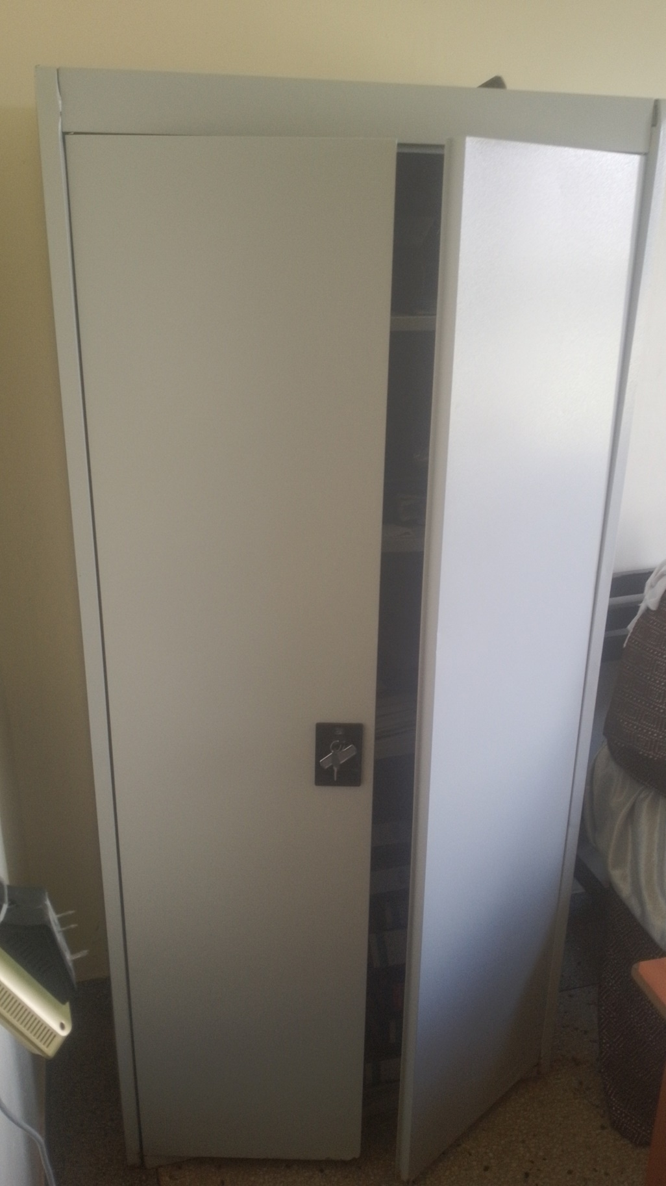
16. | FILING CABINET | 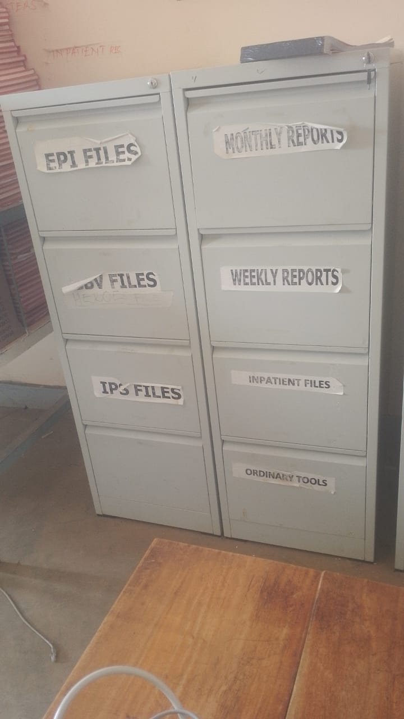
17. | REFRIGERATOR | 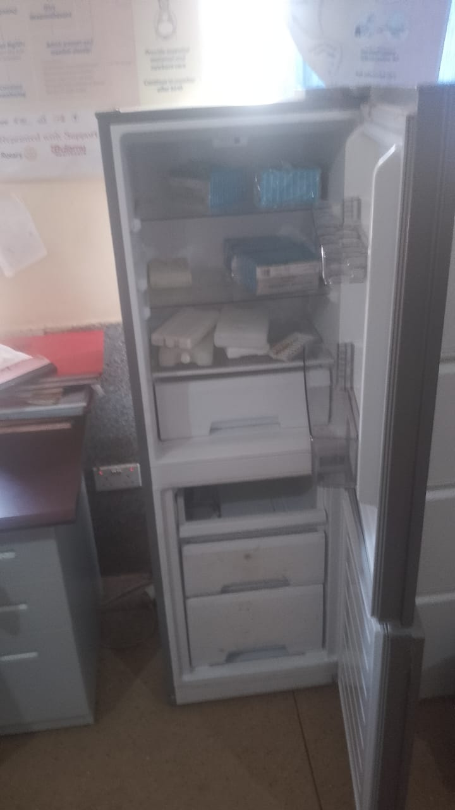
2o. | OXYGEN CYLINDER WITH OXYGYEN REGULATOR AND FLOWMETER | 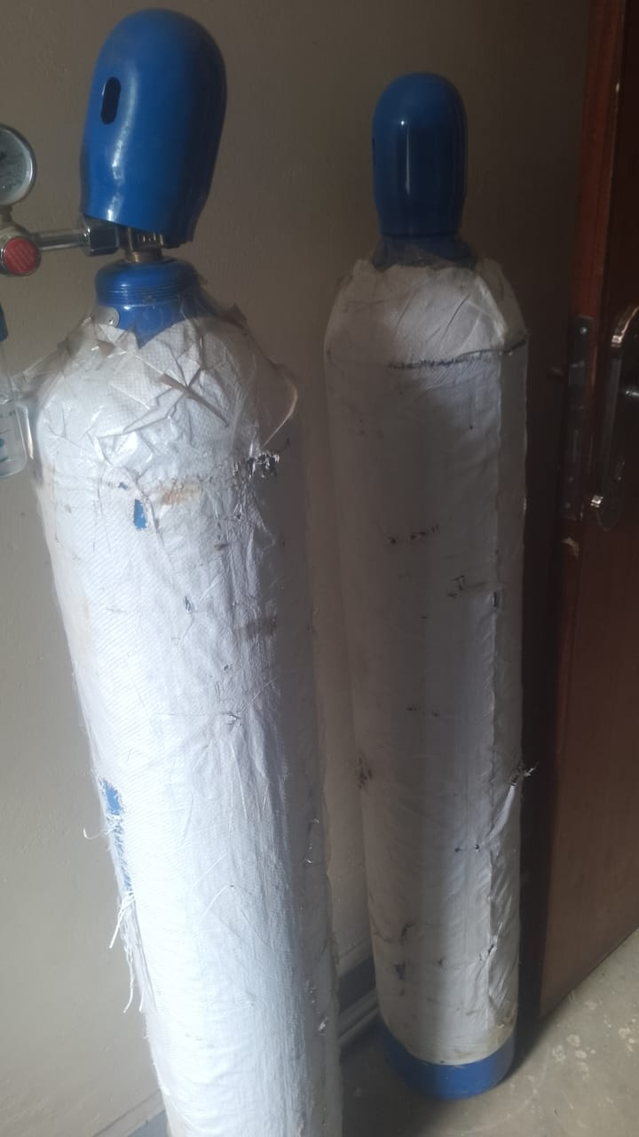

SCHOOL VERIFICATION CHECKLIST

